September 2018

Dear HSAS Families and Teachers,

Welcome to the 2018-19 school year! The PTA of HSAS’ mission is to create and maintain a welcoming and supportive environment that enriches the education of our outstanding student body. We seek to promote a cooperative relationship between parents/guardians and school staff. To further this mission, all parents/guardians and teachers are automatically members of the PTA. As such, each of you has one vote which must be cast in person, and there is no membership fee.

The PTA has many goals for this year. To help get us started, please fill out the forms that are included in this packet and return them to the school for delivery to the PTA’s mailbox in the main office.

**FUNDRAISING**: Chief among the PTA’s goals is to raise **$200,000** to support all expenses not covered by the DOE’s allocation to HSAS. In addition to office and school supplies, school trips, copier rentals, tutoring, clubs, sports and technology, the PTA has been asked to continue funding a part-time guidance counselor. To support our extraordinary school, the PTA is asking each family to donate **$750 per student**. Any amount above or below is welcome as we seek 100% participation in this endeavor. Please consider making a donation by check with the attached form or by going online at: **https://hsaspta.ejoinme.org/AnnualAppeal**. Please be aware that contributions are tax deductible due to our status as a 501(c)(3) nonprofit organization.

**BUILDING COMMUNITY**: Another major objective of the PTA is to build community. Please join us at our monthly **PTA meetings** where Mr. Weiss gives updates about our school and parents and teachers can join together to discuss issues of interest to our community. The first meeting of the PTA is on **Monday, September 17, at 7pm**, immediately following Curriculum Night. Please plan to stay for this important meeting. We will be discussing our plans for the year, electing additional Executive Board Members including a 9th grade Member at Large and 9th grade School Leadership Team member. We will also be asking for volunteers for Class Parent/Representative.

Also, for **parents of 9th graders and transfer students**, we have a **Welcome Event** taking place on

**Tuesday, October 2rd, 6-8pm** at **Mexican Festival Restaurant** — 2672 Broadway in Manhattan.

The PTA offers ways to stay informed and connected to the HSAS community. Please complete the attached Contact Form to receive **PTA newsletters and email blasts**. Also on the form, please consider joining the **PTA Directory** by checking the “yes” box, allowing you to directly connect with other HSAS families. For privacy, your street address will not be published, just your borough.

Lastly, there are many **volunteer opportunities** at HSAS. If you have time to help at an event or wish to become more involved, please complete the attached Volunteer Form. If you are not sure, please give us an idea of your skills and preferences and we will contact you as opportunities arise.

Again, welcome to the 2018-2019 school year! We look forward to seeing you.

Sincerely,

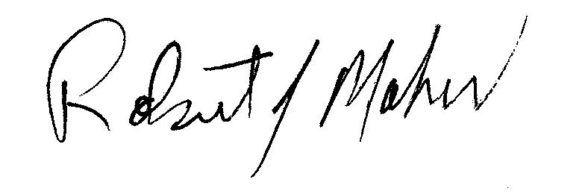

Robert Maher and Nicole Rothschild- Co-Presidents

**Save these dates for 2018-19 PTA MEETINGS. 7pm start except as noted.** 2018: Sep 17, Oct 23, Nov 13, Dec 4 | 2019: Jan 8, Feb 26, Mar 19, Apr 17 (6pm), May 21, Jun 11